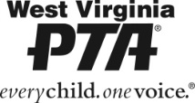
West Virginia PTA is proud to offer scholarships to graduating seniors from
West Virginia’s public high schools.
Each year, West Virginia PTA's goal is to award several $500 scholarships to qualified graduating seniors for their higher education expenses.
We appreciate the support of businesses and partners who wish to sponsor
a deserving student with this honor.

Choose Level | Sponsorship Amount
 | $250
 | $500
Other Amount | $
Payment | Check #

Business/Partner Name:
Business/Partner Address:
Business/Partner Contact Name:
Contact Phone Number:
Contact Email:
Please note any special requests in regards to this sponsorship:
REMIT FORM AND CHECK PAYABLE TO:
West Virginia PTA
Attn: SCHOLARSHIP
PO Box 3557
Parkersburg, WV 26103

