CALL FOR ENTRIES!
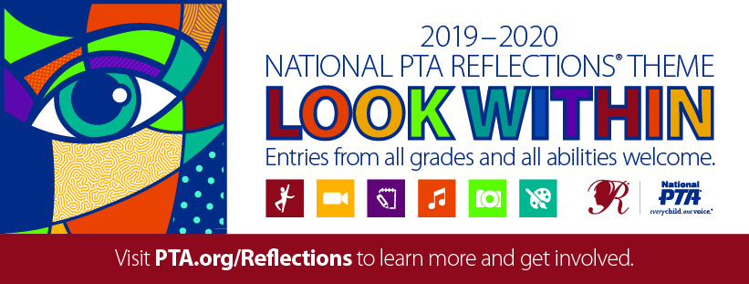
The arts − and National PTA® Reflections − support student success and serve as a valuable tool for engaging families and building strong partnerships in the school community. Founded in 1969, Reflections engages nearly 300,000 students and their families in arts education activities each year by encouraging students to explore the arts for fun and recognition.
REFLECT on the theme. CREATE art. BE RECOGNIZED!
Pre-Kindergarten through grade 12 students are encouraged to submit original works of art in one or more of the following categories:

• Dance Choreography
• Literature
• Photography
• Special Artist Division
• Film Production
• Musical Composition
• Visual Arts

Student Name: |  |  |  | Grade:
Teacher Name: |  | Parent/Guardian Name:
Parent/Guardian Email: |  | Parent/Guardian Email:
Category of Interest: Please select all that you wish to have information about.
☐Dance Choreography | ☐Film Production |  | ☐Photography
☐Literature | ☐Musical Composition |  | ☐Visual Arts
☐Special Artist Division | Return this form by [INSERT DATE HERE]

