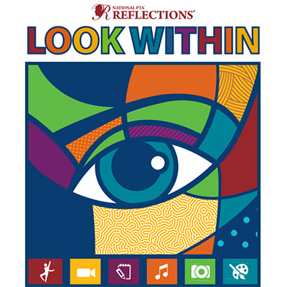
Since 1969, the Reflections program has encouraged millions of students across the nation to explore their artistic talents by creating works of art for fun and recognition. Annually, hundreds of thousands of students participate in the Reflections program through their local PTAs and we’re happy to announce our school is participating in the program!
Students in pre-school through grade 12 are encouraged to submit works of art from among six categories:

- Dance Choreography
- Literature
- Photography
- Film Production
- Musical Composition
REFLECT on the theme.
CREATE an original work.
BE RECOGNIZED!
- Visual Arts

Entries can be as simple as a picture drawn in crayon, or a photo taken on a digital camera, and there is no limit to the number of entries your child can enter. Four winners in each category and division will move on to the West Virginia PTA contest.

A Special Artist’s division is being held for students whose physical, cognitive, or mental health challenges meet ADA guidelines. (Specific information included in information packet)

Deadline for school entries:
If your child is interested in participating in the program and you would like more information, please fill out the request below and return to school. We will email a more detailed information packet about the contest including rules and requirements to those interested.

--------------------------------------------------------------------------------------------------------------------
(Please detach this portion, fill out and return by <date>)

PTA Reflections Information Packet Request
Students Name: | Grade: | Teacher:
Parent Email:

