How To Enter

National PTA’s Reflections theme: “LOOK WITHIN”

Submissions are due to <INSERT TEACHER NAME AND ROOM NUMBER> by <INSERT DEADLINE>.

Experienced artists will review your work for interpretation of theme, creativity and technique. We look forward to celebrating your artistry and achievement in the arts! Save the date for this year’s Reflections Celebration
<INSERT DATE OF AWARDS CELEBRATION>
__________________________________________________________________________________________________

Dance Choreography: Solo and ensemble works of all dance styles are accepted. Entrant must be the choreographer and may also be the performer, or one of the performers. If background music is used, cite it on the entry form. Video file must not exceed 5 min. and 1 GB in size. Accepted formats: AVI, FLV, WMV, MOV, MP4.

Film Production: Accepted short film styles include: Animation, narrative, documentary, experimental or media presentation. Use of PowerPoint is prohibited. Entrant must be the screenwriter, cinematographer, editor and producer. If background music is used, cite it on the entry form. Video file must not exceed 5 min. and 1 GB in size. Accepted formats: AVI, FLV, WMV, MOV, MP4.

Literature: Accepted forms of fiction and nonfiction include: Prose, poetry, reflective essay, screen play and play script, narrative, and short story. Entrants may write in their primary language as long as an interpretive English translation is also attached. Use of copyrighted material is prohibited. Writing must not exceed 2,000 words and may be handwritten or typed. Accepted formats: Single-sided print on 8 ½x11” paper, PDF file.

Music Composition: All music styles and combinations of instrumentation are accepted. Entrant must be the composer and may also be the performer, or one of the performers. Use of copyrighted material is prohibited. Audio file must not exceed 5 min. and 1 GB in size. Accepted formats: MP3, WMA, WAV, ACC, FLAC. Notation (score/tablature) in PDF format is only required for middle and high school divisions.

Photography: Photo must be a single print/digital image. Collages and collections of photos are not accepted. Entrant must be the photographer and may use a variety of digital editing techniques including but not limited to, multiple exposure, negative sandwich and photogram. Use of copyrighted material is prohibited. Print image dimensions must be no smaller than 3x5 inches and no larger than 8x10 inches. Accepted print formats: Mounted on mat or poster board no larger than 11x14 inches. Framed prints are not accepted. Digital image dimensions must be at least 640x960 (pixels) and 300 dpi (resolution). Accepted file formats: JPEG, JPG, GIF, PNG.

Visual Arts: Works of both fine and design arts are accepted, including but not limited to: architectural drawing and models, ceramics, collage, computer generated images and graphics, crafts, drawing, fashion clothes and jewelry, fiber work, mixed media, painting, printmaking and sculpture. Use of copyrighted material is prohibited. 2D artworks must be mounted on sturdy material and no larger than 24x30 inches with matting. Framed entries are not accepted. Include one digital image of artwork with your submission. 3D artwork submissions must contain 3 digital images of artwork at different angles. Image(s) are used for artwork identification, judging and exhibition purposes.

Special Artist: Students who identify as having a disability and may receive services under IDEA or ADA: Section 504 may enter in the Special Artist Division or grade division most closely aligned to their functional abilities. See Official Rules for details.
Official Rules

By submitting an artwork to the “National PTA Reflections Program,” entrants accept and agree to be bound by the official rules for participation as well as the entry requirements for their specific arts category and division. Additional state program requirements may apply. Any violation of these rules may, at PTA’s discretion, result in disqualification. All decisions of the reviewers regarding this program are final and binding in all respects. (The “PTA” referred to in these rules include all PTAs reviewing the submission).

- ELIGIBILITY. Students must participate through a local PTA/PTSA. Each student’s eligibility is determined by the state and local PTA/PTSA. A student may develop an entry inside or outside of school.
- ARTS CATEGORIES. There are six arts categories—dance choreography, film production, literature, music composition, photography and visual arts. Students may enter the National PTA Reflections Program in one or more arts categories. See each arts category rules for additional entry requirements.
- GRADE DIVISIONS. Students may enter in the appropriate division for their grade (Primary: Preschool-Grade 2; Intermediate: Grades 3-5; Middle School: Grades 6-8; High School: Grades 9-12; Special Artist: All grades welcome).
The Special Artist Division welcomes students from all grades and abilities and offers non-artistic accommodations (e.g. adaptive technology; transcribing; holding a camera) for students to participate fully in PTA Reflections. Assistants must refrain from being involved in the artistic process (e.g. developing an artist statement, choreography, music lyrics, storyboards, etc.) Student recognition and awards are announced as part of the Special Artist Division.
- HOW TO ENTER. Entrants must submit their artwork and student entry form to their local PTA/PTSA program according to local and state PTA procedures. Entrants must follow requirements and instructions specific to each arts category and division. Contact local PTA programs for deadlines and additional information.
- ENTRY REQUIREMENTS. (All participants must also follow arts category and if applicable, Special Artist Division rules)
- Only new pieces of artwork inspired by the current year’s theme may be submitted.
- Each entry must be the original work of one student only. An adult may not alter the creative integrity of a student’s work. Because the program is designed to encourage and recognize each student’s individual creativity, help from an adult or collaboration with other students is not allowed except in the Special Artist Division. Other individuals may appear in or perform a student’s work, but the work itself must be the creative product of one student only. Only one student may be recognized as the award recipient for each entry. See the specific arts category rules and special artist division rules for details.
- Each entry must contain a title and all entries must include an artist statement. The artist statement communicates what inspired the work, how it relates to the theme, and the content of the work. The statement must include at least 10 words and not exceed 100 words.
- Use of copyrighted material is prohibited, except for background music in dance choreography and film production entries. If used in dance choreography and film production entries, background music must be cited on the entry form. Plagiarized entries will be disqualified. Use of PowerPoint templates are prohibited.
- FINALIST SELECTION AND NOTIFICATION. Entries are reviewed at local, regional, state and national levels. Each PTA determines its own reviewers for the program. Entries will be reviewed primarily on how well the student uses their artistic vision to portray the theme, their originality and creativity. National PTA reserves the right to use its sole discretion in selecting the submissions to be recognized at the national level. Under no condition may parents or students contact a reviewer to dispute the status/score of any entry. Each PTA in its sole discretion will select finalists for exhibition and provide awards/prizes. Awards are announced per local and state procedures. National awards and events are announced May 1, 2020 at PTA.org/Reflections.
- OWNERSHIP AND LICENSE. Ownership in any submission shall remain the property of the entrant, but entry into this program constitutes entrant’s irrevocable permission and consent that PTA may display, copy, reproduce, enhance, print, sublicense, publish, distribute and create derivative works for PTA purposes. PTA is not responsible for lost or damaged entries. Submission of entry into the PTA Reflections program constitutes acceptance of all rules and conditions.
- PARTICIPATING ENTITIES. This program is administered by the National Parent Teacher Association (PTA) and PTA affiliates. Parent groups not affiliated with National PTA are not eligible to sponsor this program.
2019-2020 Student Entry Form
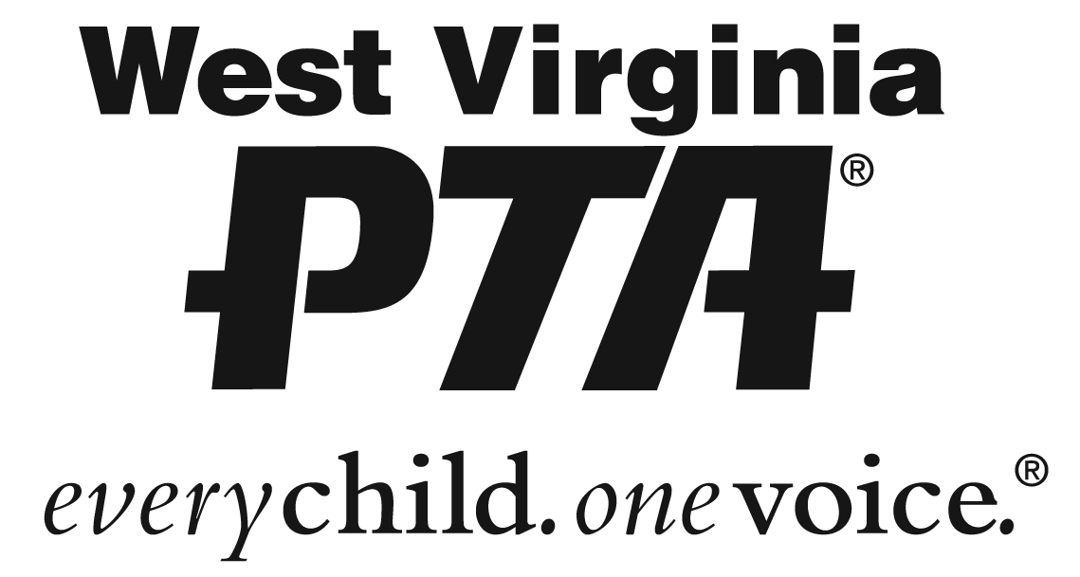

To be completed by PTA before distribution.
LOCAL PTA ___________________________________________ LOCAL PTA ID ___ ___ ___ ___ ___ ___ ___ ___
LOCAL PROGRAM CHAIR________________________________ EMAIL_____________________________ PHONE_____________________
COUNCIL PTA__________________ DISTRICT PTA__________________ REGION PTA__________________ STATE PTA __________________
MEMBER DUES PAID DATE ________________ INSURANCE PAID DATE__________________ BYLAWS APPROVAL DATE__________________

STUDENT NAME _______________________________ GRADE ______ AGE ______ CLASSROOM __________
PARENT/GUARDIAN NAME ______________________ EMAIL ________________ PHONE ________________
MAILING ADDRESS _____________________________ CITY ______________ STATE _________ ZIP _______
Ownership in any submission shall remain the property of the entrant, but entry into this program constitutes entrant’s irrevocable permission and consent that PTA may display, copy, reproduce, enhance, print, sublicense, publish, distribute and create derivative works for PTA purposes. PTA is not responsible for lost or damaged entries. Submission of entry into the PTA Reflections program constitutes acceptance of all rules and conditions. I agree to the above statement and the National PTA Reflections Official Rules.

STUDENT SIGNATURE _______________________ PARENT/GUARDIAN SIGNATURE ____________________

GRADE DIVISION (Check One) ARTS CATEGORY (Check One)
PRIMARY (Pre-K-Grade 2) DANCE CHOREOGRAPHY
INTERMEDIATE (Grades (3-5) FILM PRODUCTION
MIDDLE SCHOOL (Grades 6-8) LITERATURE
HIGH SCHOOL (Grades 9-12) MUSIC COMPOSITION
SPECIAL ARTIST (All Grades) PHOTOGRAPHY
VISUAL ARTS

TITLE OF WORK ____________________________________________ DETAILS _________________________
If background music is used in dance/film, citation is required. Include word count for literature. List musician(s) or instrumentation for music. List dimensions for photography/visual arts.
ARTIST STATEMENT (In 10 to 100 words, describe your work and how it relates to the theme)
__________________________________________________________________________________________
__________________________________________________________________________________________
__________________________________________________________________________________________
__________________________________________________________________________________________
__________________________________________________________________________________________

