WEST VIRGINIA
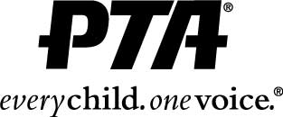

‘

Date: November 1, 2018

To: All West Virginia High School Counselors/Principals

From: West Virginia PTA Scholarship Committee
Linda Abercrombie, Chairperson

Re: 2019 West Virginia PTA Scholarship

The West Virginia PTA is proud to announce that five scholarships were given to graduating seniors in 2018 and each scholarship was in the amount of $500. This year, five (5), $500 scholarships will be presented to all winners at the 2019 West Virginia PTA convention.

I have enclosed an application packet with all the information required. Please make copies for all interested seniors at your school. We strongly encourage all students who are planning to attend vocational school, college or any other institution of higher learning to apply for our scholarship. There is no limit to the number of students that may apply from your school.

Please be sure that students have read the rules and requirements included in the packet. All completed applications should be sent to the Scholarship Selection Committee at the address below. Applications must be received by December 31, 2018.

Scholarship applications may also be downloaded by visiting our West Virginia PTA website (www.westvirginiapta.org), but all completed applications must be mailed and received by the deadline above.

If you need further information, please contact:

Linda Abercrombie, Scholarship Chair
P.O. Box 218
Follansbee, WV 26037

Email: scholarship@westvirginiapta.org
Cell: 304-670-7468

