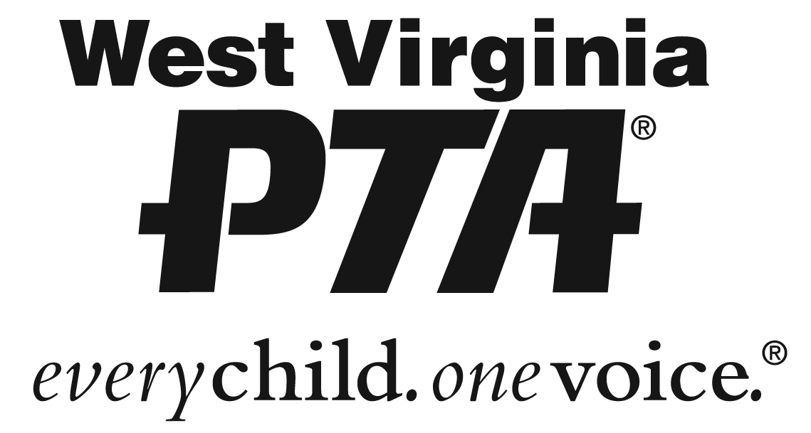

West Virginia PTA Scholarship Rules and Requirements
2018-2019
The amount of the scholarship will be $500.

The scholarship recipient(s) must be a high school senior in a WV school.
Applicants must have a 2.0 grade point average.
This scholarship must be used for tuition/educational expenses in any vocational, college or institution of higher learning approved by the Scholarship Committee. It may not be used for living or personal expenses.
The scholarship recipient may accept another source of financial aid or scholarship.
A high school transcript must be submitted with the application.
Scholarship Application must be received by December 31, 2018.
The final decision on awarding a scholarship shall be made by the scholarship committee.
The Scholarship Committee is comprised of members of the West Virginia PTA Board of Managers and PTA members from across the state.
Payment of the scholarship shall be in the form of a check made payable to the approved school to be used for tuition/educational expenses only.
Criteria for Selection of Scholarship Recipient(s):
- Overall quality of application and submitted materials
- Volunteer Service, Leadership, Honors Received, and Extra-Curricular Activities
- Recipient(s) shall be selected without regard to race, color, religion, sex, national origin, disability or geographical location.
Incomplete application will not be considered.
Checklist:
_____Application Completed
_____Official Transcript
_____PTA Reflection (one page limit)
_____Long-Term Goals Essay (one page limit)
_____Letters of Recommendation (no more than three, one page each)

For further information, please contact: Linda Abercrombie, Scholarship Chairman
Email: scholarship@westvirginiapta.org Phone/Text: 304-670-7468

