NATIONAL UPDATE
Official Publication of the Sons of The American Legion
Summer 2016
Queen Ci_!y hosts National Convention
Cincinnati is known as the Queen City. Hundreds of Sons will flock to this thriving Ohio River town in late August for the organization's 45th National Convention of the Sons of The American Legion.
The convention gets underway on Friday morning, August 26 with committee meetings and the pre-conven­ tion National Executive Committee meeting Room 232. Promptly at 1pm, S.A.L. National Commander Kevin Collier will call delegates to order in the Duke Energy Convention Center 's Grand Ballroom B. General ses­ sions will continue throughout the afternoon Friday, then start up again early on Saturday and Sunday. Year-end reports and visits from a variety of Legion and non-American Legion special guests will take place throughout the three day convention. On Sunday, convention delegates will elect the organization's newest national of­ ficers, including the next National

Commander of the Sons.
Also on Sunday, The American
Seven would've been a slice of heaven

Legion Family is encouraged to at­ tend the annual Patriotic Memorial Service. This year's memorial ser­ vice starts at 11am on the first floor of the convention center in Exhibit Hall A.
The S.A.L.'s 45th National Con­ vention will conclude on Sunday afternoon in time for Sons to par­
-"-'-cipate in the annual American Le-
- .on Convention Parade that will run through downtown Cincinnati
on Fifth Street. The parade route and Department line-up schedules
Continued on Page 3
When Kevin Collier was elected
National Commander of the Sons last summer he set a goal of raising
$600,000 for The American Legion Child Welfare Foundation. The reason behind that goal was the fact Sons have, since i988, raised more than $6 million for CWF. Collier wanted to top the $7 million mark during his administration and as he traveled around the country all year, he could be heard saying at each stop, "Wouldn't it be a little piece of heaven when we reach seven?"
We came oh-so-close.
By the end of the business day on May 31, S.A.L. contribu­ tions delivered to The American Legion 's National Headquarters totaled $360,299 for the 2015-16 year. It was another banner year that now guarantees S.A.L. dona­ tions for next year will, indeed, put the organization over the $7 million mark in all-time contribu- tions.
National Commander Col- lier and National Adjutant Brian
Continued on Page 3

You guys really know how to ROCK on

Getting involved in

By Kevin Collier
National Commander
Fellow members of the Sons, each of us made a commitment when we chose to become members of the Sons of The

VEE at the ground level and up

American Legion, to always honor our veterans through duty, honor and
service to The American Legion's four pillars of Americanism, Veteran's Affairs & Rehabilitation, Children and Youth and National Security.
This year we chose a theme of "R.O.C.K.E.D." which stands for "Re­ membering Our Commitment, Keeping it Every Day." As I traveled across this great nation visiting with various Detachments it was evident that we have not forgotten that commitment. During my travels I was able to wit­ ness some of the accolades the Detachments were able to bestow upon their districts, counties, areas, squadrons and members for all the hard work they have done for their communities, their veterans, our youth and our member­ ship. Ithas been a great honor for me to see and hear about the accomplish­ ments achieved.
Looking forward to the future of the Sons of The American Legion, we have established a Strategic Planning Initiative Committee. This commit­ tee is similar to the one that The American Legion had about six years ago and the one The American Legion Auxiliary had about three years ago. The Strategic Planning Initiative Committee has been asked to look at the future of our organization , to establish a vision and goals of where we want our organization to be moving toward. They will perform a S.W.O.T.(Strength, Weakness, Opportunities, Threat anal sis of the Sons of The American Legion. They will be looking for any strategic issues that we must ad-

By Larry "Bear" Weinzirl Nat'/ VE&E Chairman
The Mission Statement of the newly formed SAL National Vet­ erans Employment and Educa­ tion Commission is "To assist The American Legion in ensuring that America's veterans have the op­ portunity to provide, with honor and dignity, the economic necessi­ ties of life for themselves and their families."
We need your help to accom­ plish this.
We are requesting that all detach­ ments, districts and squadrons form their own VEE subcommittees un­ der VAVS to help get the word out on "Hirin Our Heroes" ·ob fair Members of these subcommittees

Continued on Page 7 can assist by going online and find­
ing local job fairs being held in

Service to God and country at our core
your communities. Then, take that information, as well as information

By Tom Chebro
Nat'[ Americanism Commission
America was founded upon the received from National or Detach­ idea that The Great Creator of Man ment HQ, and place it on your own endowed each and every human be- websites, Facebook pages, and in ing with certain inalienable rights, your newsletters. You should also

including life, liberty, and the pursuit of happiness. Our brave men and print fliers advertising thejobs fairs women have served around the world protecting those God-given rights. and post them on the bulletin board Every Post, Unit, and Squadron has a Chaplain. Ask yourself this, at your post and in other locations "Were they given the position because there was nobody else? Are they around your community where vet­ able to give spiritual help? Are they there just to give a prayer before and erans will see them. Also, possibly after our meetings?" request that your post e-mail this
Religious emphasis has taken a back seat in America for some time information out to all members. now. The American Legion Family needs to help bring it back. When a person · leaves the
Just a few years ago, at The American Legion's 2014 Chaplains Con- military, the biggest question is, ference, they came up with an action item called "Operation: Back to "What's next?" You can help pro­ God." During that conference, three working groups were organized for vide the answer to that question by the purpose of placing this initiative before all members of The American distributing job fair information Legion Family. What they proposed included: our veterans.
- Developing a training curriculum for future Chaplains Please help as we work at all
- Awarding and recognizing the work of Chaplains levels of the S.A.L. to assist the
- Publicizing what Chaplaincy does and how it can affect the very nature "Heroes" who have kept America of what The American Legion Family stands Continued on Page 8 and everyone in it free and safe.

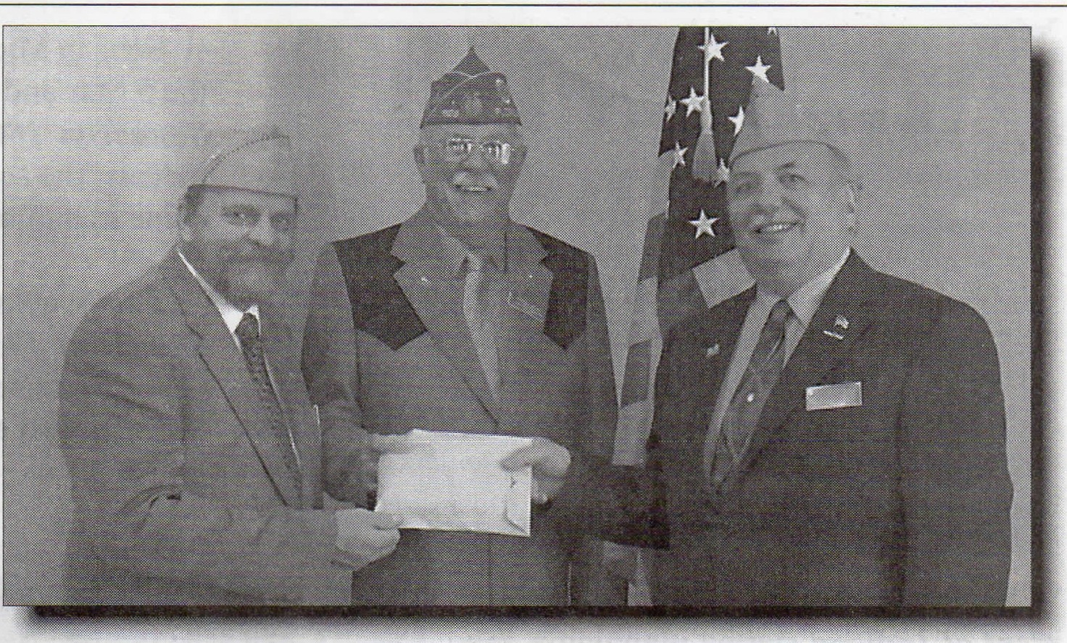Convention from Page l
-----,nd much more information can be '"ound at www.legion.org/conven­ tion.
Delegates and guests to the con­ vention are registered in advance through their respective Detach­ ments. Representatives of each Detachment can pick up creden­ tials in the S.A.L. Convention Of­ fice located in the Junior Ballroom (3rd floor) of the convention center beginning Thursday, August 25.
No specific dress code is re­ quired during the convention,
however, there are some guide- Above - National Commander
lines. Delegates who expect to be Collier and CWF Chairman Pete on stage to receive awards are ex- Sierminski present American Le­ pected to wear a coat and tie. 0th- gion Child Welfare Foundation erwise, trousers, shirts and shoes President Dennis Boland with always look nice when dignitar- donations from the spring N.E. C. ies and special guests pay a visit. meetings totaling an incredible
.,......._Shorts, tank top shirts and flip-flops $101,163.
re discouraged.
Nearly all official convention hotels are located in downtown
Cincinnati within a few blocks of the convention center. Shuttle busses
will move delegates between their hotels and the Convention Center. On Friday, the shuttles will run from 7am to 8pm, until 5:30pm on Saturday and until 2:30pm on Sunday.
Delegates and their families will have much to see and do while at­ tending the convention. Golf enthusiasts will be glad to hear the Detach­ ment of Ohio is sponsoring a golf tournament Thursday morning, August
25. Nearby Mason, OH Squadron 194 is offering a homemade pizza dinner and entertainment Thursday evening. The Detachment of Ohio will be serving a dinner featuring popular Cincinnati foods on Friday evening at Milford Post 450. Shuttle busses will be offered from a down­ town location for both dinners.
Cincinnati is home to two major sports teams, the Cincinnati Reds, the oldest franchise in Major League Baseball, and the Cincinnati Bengals of the National Football League. The Queen City is also famous for its Cincinnati style chili. More than 140 chili restaurants can be found here.
Cincinnati is known for its historic architecture, commonly referred to as "Paris of America" a century ago. The John A. Roehling Suspension Bridge spans the Ohio River between Cincinnati Covington, KY and was nee the longest suspension bridge in the world at 1,057 feet. Pedestri­ ans use the bridge to get between the sports venues in Cincinnati and the hotels, bars, restaurants, and parking lots in Northern Kentucky, known as Roehling Point. If the bridge looks familiar, there's a good reason. Roehling also designed New York's famous Brooklyn Bridge.

CWF from Page 1
O'Hearne provided a pat on the back to the Detachment of Ohio for contributing $50,966, the most of any state. Other Detachments that contributed more than $10,000 each included Indiana ($42,670), Arizo­ na ($23,820), California ($18,187), Colora o , on a ($25,600), Nevada ($10,028), and Pennsylvania ($31,754).
Another way to measure Ne­ vada's contribution is to consider that it amounted to $28.57 for each
S.A.L. member in the state. The next closest per capita amount was delivered by the Detachment of Colorado ($5.54). Other sizeable per capita amounts included Or­ egon ($5.42), Mississippi ($4.10), Wyoming ($3.83), and Arizona ($3.57).

Ever wonder what·Legion programs your squadron could be involved in to help veterans? To have fun?
Youth programs?
Take -a look at:

www.legion.org/programs

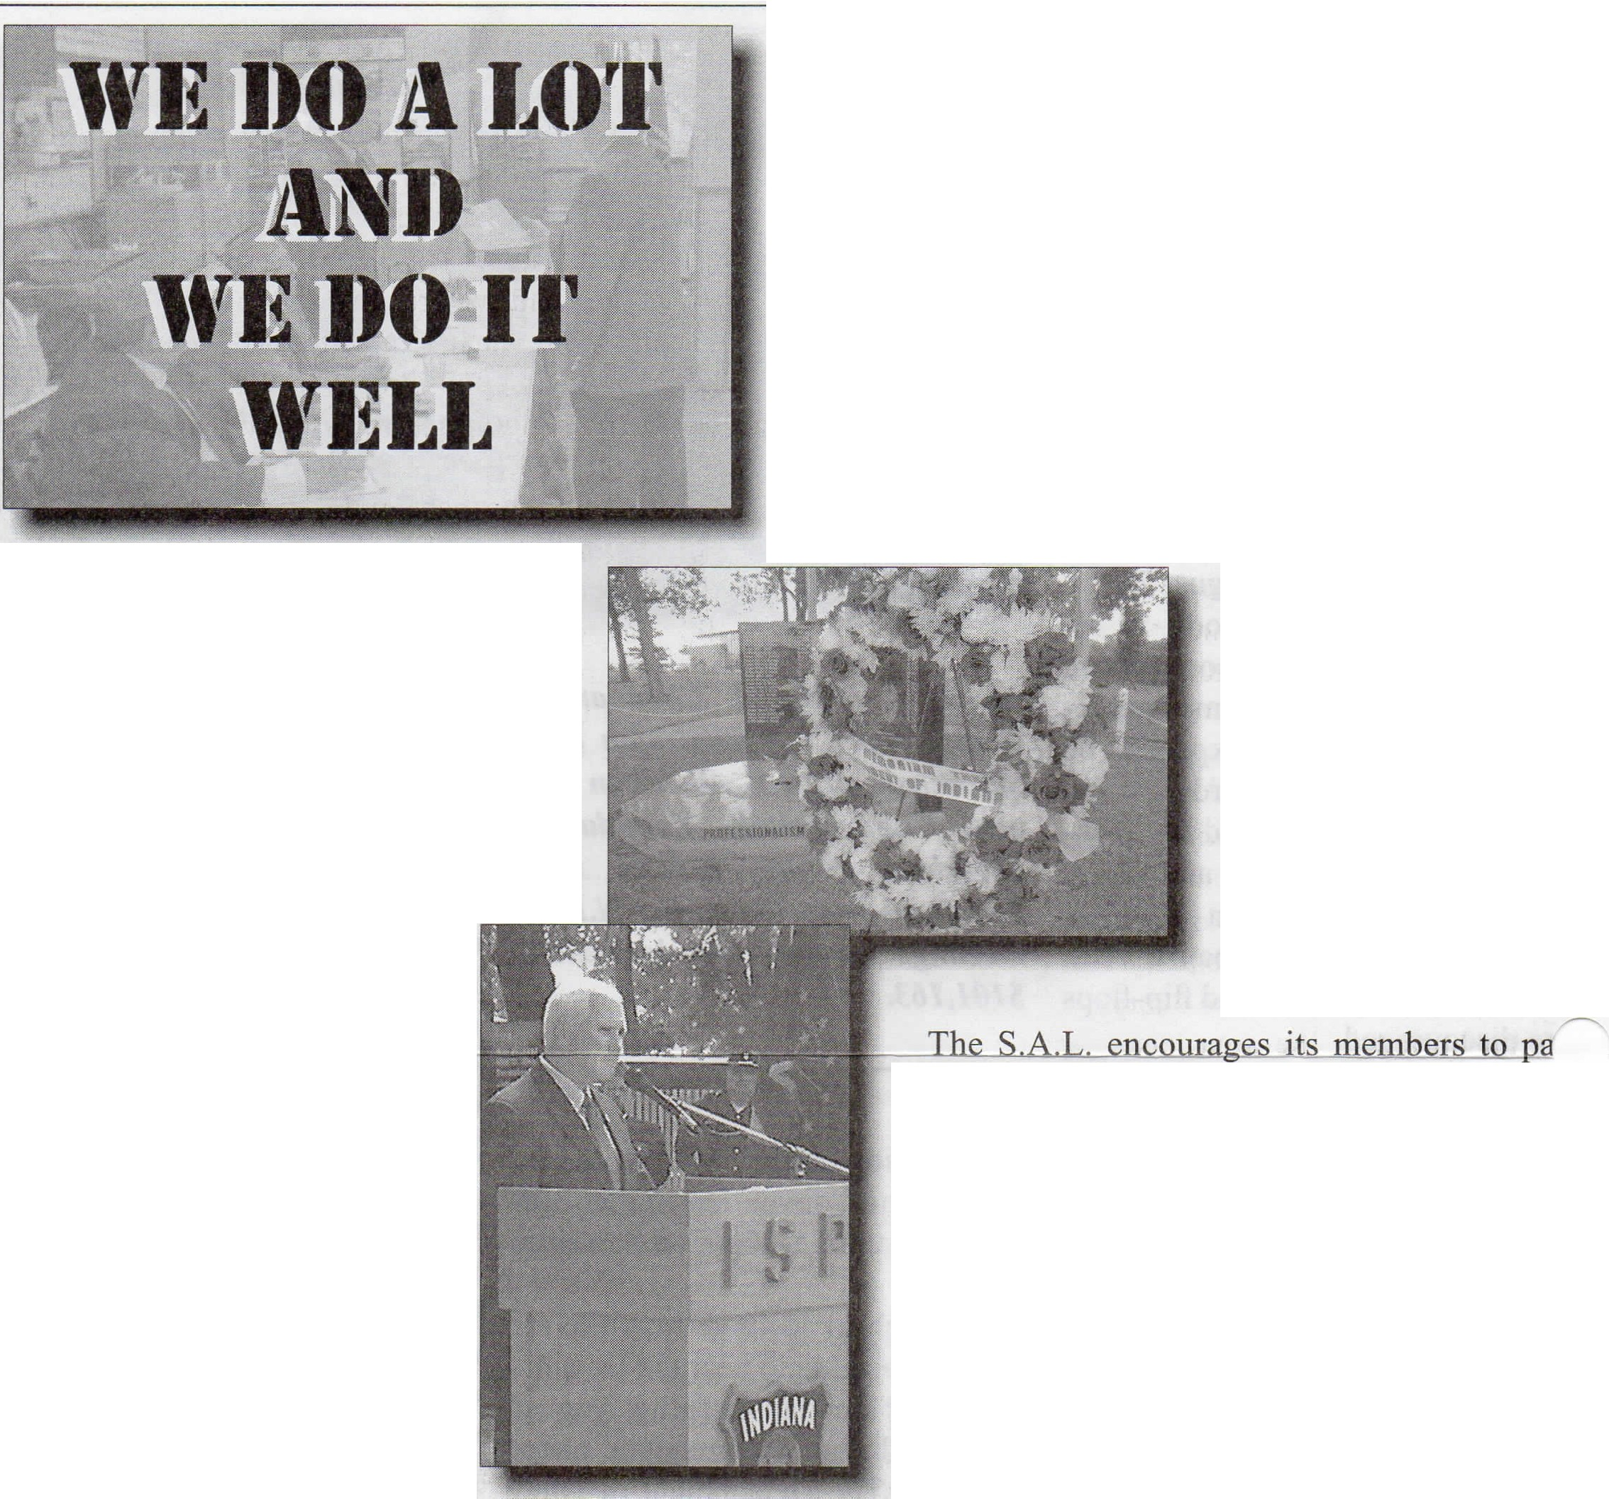Sons in Michigan know what an honor it is to earn the 5 Star and 10 Ideals medals. When Hudson, MI Squadron 180 had two young members earn the· medals, the squadron invited Detachment officers to come in and make the presentations.

That's a lot of noodles! Sons of Ohiowa, NE Squadron 193 held a beef and noodle dinner this year and raised $1,400 that was given to Quilts of Valor project and a Fillmore County military support group.

Back in February, when the Detach­ ment of Indiana started planning a July ceremony to honor members of the In­ diana State Police who lost their lives in the line of duty, (Above Right) they had no way of knowing their intimate ceremony would wind up being covered by regional and national news organiza­ tions. In an awful coincidence,
five Dallas police officers were killed the night before and one of the scheduled speakers at the memorial was Indiana's gover­ nor, Mike Pence, who was about to be named the running mate of
U.S. presidential hopeful Don­ ald Trump. Unfortunate cir­ cumstances actually led to the
S.A.L. being shown in a very positive light. (Right)

A few years ago, Sons in Bethel Park, PA Squadron 760 came up with an idea that
has received good results. They appointed S.A.L. mem­ ber John Dunbar as their School Liaison Officer to help promote Legion programs to youth in the community. He has worked tirelessly overseeing two scholarship programs and distributes educational materials to local schools. The idea has paid off. In the past year the post has held its first Oratorical Contest, entered essays into the National Essay Contest, and sent students to the Allegheny County Youth Achievement Dinner.

Oakville, CT Squadron 195 held its first annual Game Dinner this year and raised enough money to donate $1,000 each to Fisher House Connecticut and K9's for Warriors.
Our hats are off to two Sons making us proud in Michigan. Iron Moun­ tain, MI Squadron 50 has two members, Den­ nis Larson and Steve Podgornik, who have each served the past 17 years as VAVS Reps in the Iron Mountain VA Medical Center.

tlc1pate in its National Veterans Assistance Day each year in May. Sons from Wiloughby, OH Squadron 214 multiplied that idea. They completed a four-day, 70 mile walk from their post to the Ohio Veterans Home in Sandusky. Their efforts raised over $7,000 for the home. (Below)

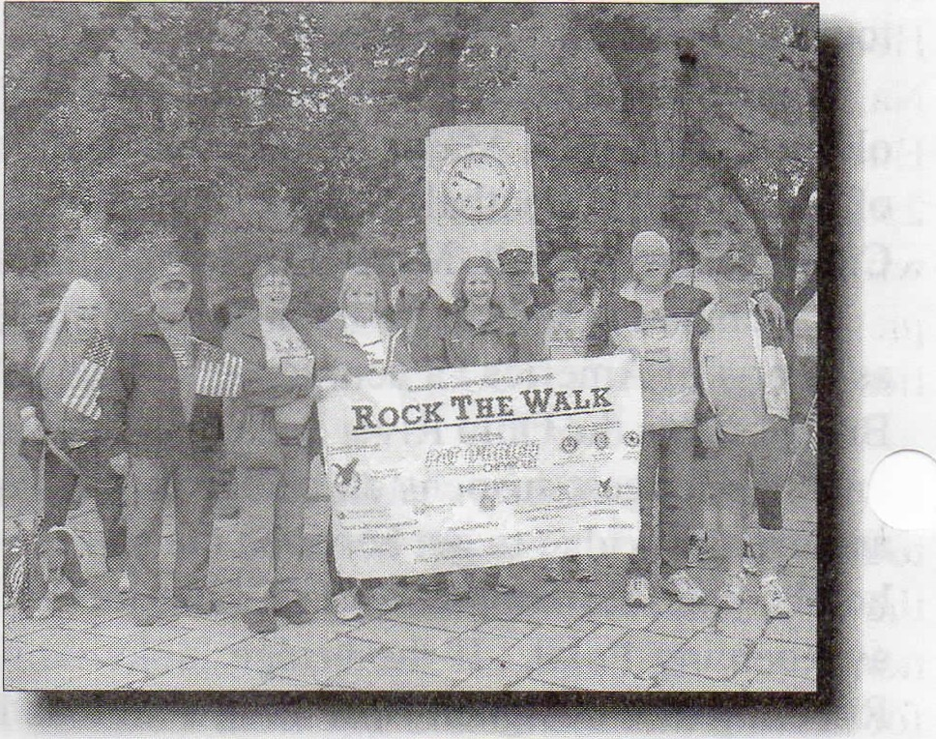
When the Indio, CA Post 739 color guard won First Place in the Riverside County Fair and National Date Festival Parade this year, they were led by their four 12 year old grand-

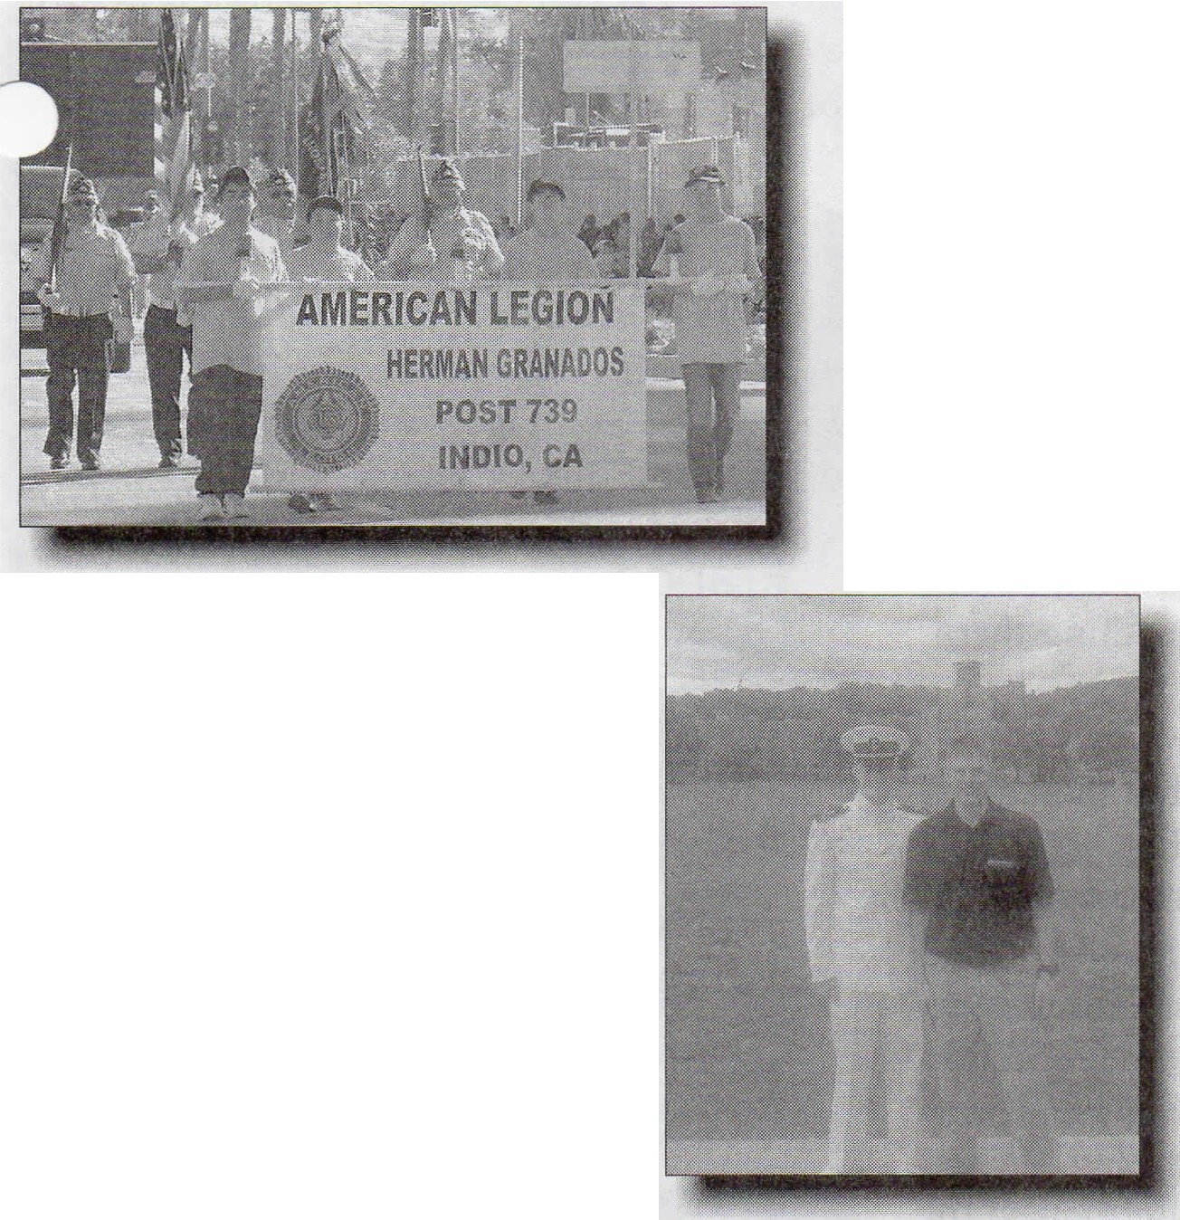
Traumatic Stress and Traumatic Brain Injury.

Here are two examples of S.A.L. members who know the im­ portance of scholarship. Patrick and Sean Coyle are members of Oxford, CT Squadron 174. Back in 2013, Patrick was Valedic­ torian of his high school class. He's gone on to college with a full NROTC scholarship and was recently promoted to the rank of Midshipman. This year, Sean graduated as Valedictorian of his class and has accepted an appointment to West Point, his high school's first-ever USMA appointment. (Below Left)

sons, each of them members of the S.A.L., another example of how Sons of all ages can support their parents, grandparents, The Legion and their community. (Above)

Sebastian, FL Squadron 189 has started an Operation: Re­ member Our Heroes program. Squadron members and local high hool JRROTC make sure every
teran buried in th_e ar_ea has a bronze grave marker and has a flag placed twice each year. They've taken care of nearly 400 veteran graves, cataloging each of the names, ranks, ser­ vice branch and locations. It's all been paid for through pri­ vate donations. (Right)

Can you guess which mem­ ber of Norfolk, KS Squadron 16 has been named Volunteer
of the Year for the Norfolk Veterans Home? None other than our very own National Assistant Adjutant (Emeritus), Harold E. Thompson, Jr. For more than 25 years, he has called bingo, assisted with horse racing, and baked delicious pies and brownies for suppers and activi­ ties. (Right)
,,,------...
Napa, CA Squadron 113 holds a golf tournament each year in May and gives the proceeds to the Pathway House, a non-profit residential recovery program for service members suffering from Post
Over the past eight years, Riverview, MI Squadron 389 has awarded over $4,000 in college scholarships to graduating high school students. The interesting twist is that the recipient must have an immediate family member in the armed services, conduct an in­ terview with that service member and write an essay about it.

Harry Warren is a member of Berlin, MD Squadron 123. He became the 64th member of his Boy Scout Troop to earn the rank of Eagle Scout and even received a congratula­
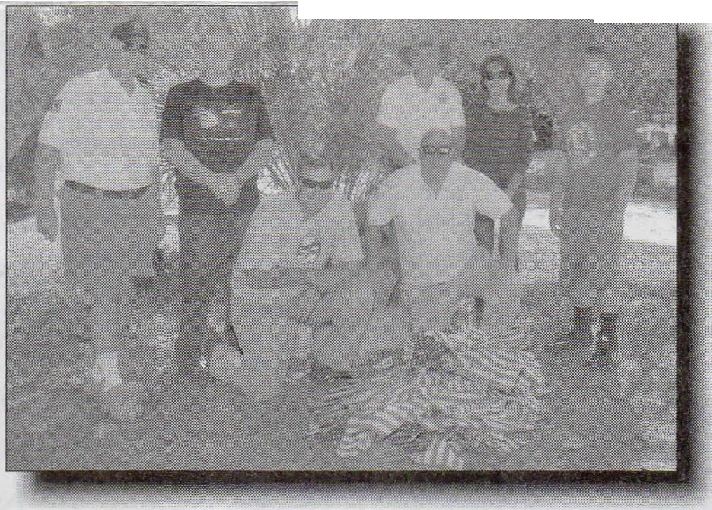
-;i=m>i...,,;;;......ifuiiii..;a;a;;......,iiiiiiij" - ory-1.etter signe_._,w..,·.iu.cu_.
and Mrs. Obama.

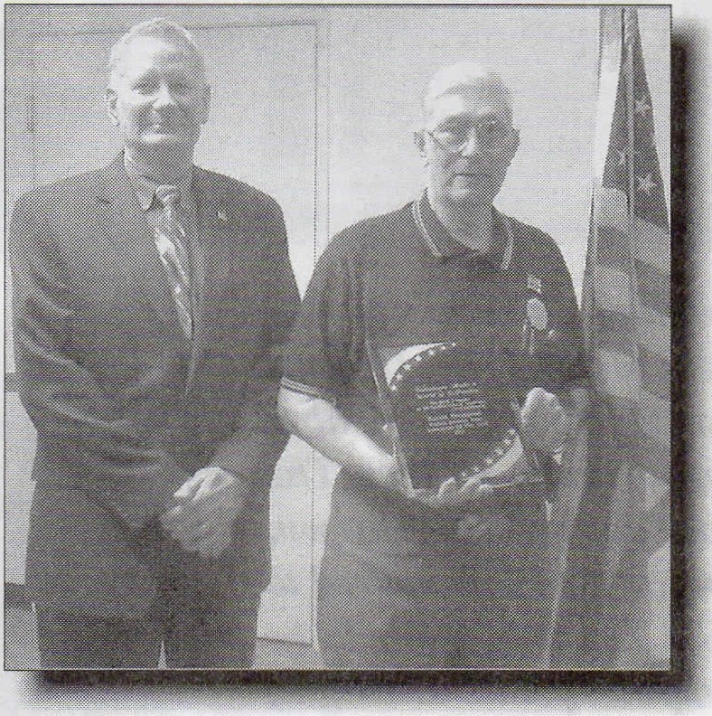
Wisconsin's Legion Depart­ ment operates Camp American Legion along the shores of Big Carr Lake. The camp serves more than 500 disabled and recently active duty veterans and their families each sum­ mer. Hartland, WI Squadron 294 has a tradition of sending four of its members to the camp in late April each year to help get it ready
for summertime. It's chal­ lenging work because they don't know what has to be done until they get there. Chores this year ranged from fixing bat houses atop 12 foot poles and installing a retaining wall around a playground. Before leav­ ing, the guys presented the

Continued on Page 6

Do it Well from Page 5
camp director with a $1,000 donation.
Membership
2016 Leaders

Although not officially sanctioned, supporters of Ameri­ canism activities have been contributing photos and stories to their "SALAmericanism" Facebook page for the past year. They use it as a bulletin board to post events, activities, and squadron or Detachment information related to Americanism in any way. The site has been averaging about 900 hits each week and that number has been growing. Members of the
Phi l i ppir]eS Nevada '
163 o/o

154 %
122 %

113 %
113' o/o

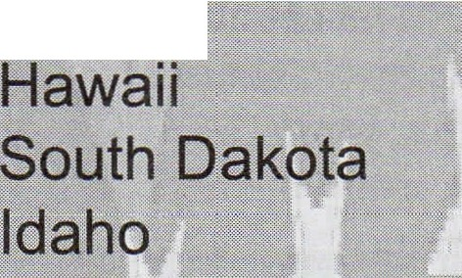
S.A.L. National Americanism Commission have been volun­ teering to serve as administrators. To post something there, send it to ggibbs@sbu. edu.
France 109 °/o
Utah 107 %
North Cprolina 105 °/o

Des Plaines, IL Squadron 36 may be new but they don't Montana 104 °/o act like it. Less than three months after holding their first Puerto Rico 103 % election of officers, the squadron gathered together more than Wisconsin 03 0; 60 volunteers, including seven Boy Scout Troops, and placed North Dakota 103 % flags on more than 4,000 graves at the largest cemetery in
0
Cook County. The Sons purchased those flags with $3,000 Oregon 102 °/o
in donations they collected and, for the first time ever, all vet- Florida 102 0 0
eran graves at All Saints Cemetery had its own flag. When I nd iana 102 o;
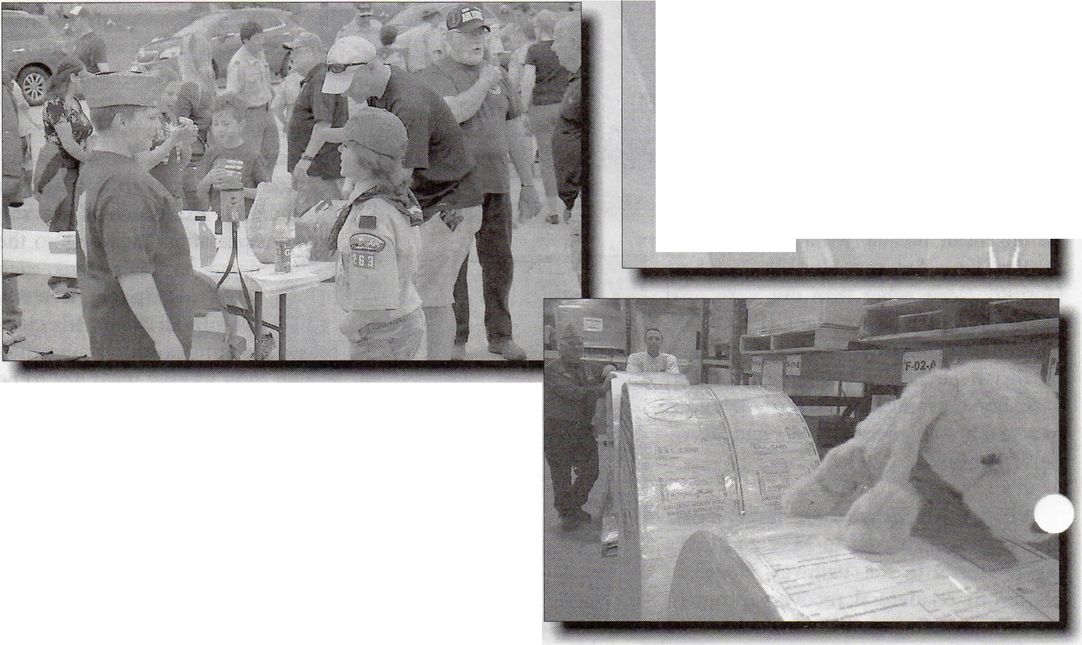Squadron Commander Kevin O'Connell was interviewed for 0
a newspaper story he sa· starte_d the program to honor_ i-_M_i_ch i _a_n_, 1_0_1_o/_co
the service of his father, a WWII veteran and Legionnaire. |  | Pennsylva nia | 100 %
(Below) |  | Alaska | 100 %
 |  | Wyoming Ill i nois | 100 °/o  100 %
 |  | Min nesota | 100 %
 |  | Arkansas | 100 °/o
 |  | Massach usetts | 100 °/o
 |  | California | 100 %
 |  | N{I Total | 99 %

The logistics involved in printing close to 400,000
S.A.L. cards each year ispretty staggering. In May, National Chaplain Mike Lawler (WI) was visiting Indianapolis and had an opportunity to tour The Legion's printing facilities out on the edge of town. He and his Josh Dog look pretty small compared to the massive rolls of blank S.A.L. cards ready to be loaded onto the oversized computerprinters. (Right)

Collier from Page 2
------- ss within the next five years to
..,..,ntinue to grow and become even more of a vital part of The American Legion Family.
As we all prepare to gather at the National Convention in Cincinnati, Ohio to complete this year's busi­ ness, I want to thank every member of this great organization for your service to our veterans, our com­ munities and our youth. You have made this an amazing year and I thank for your hard work and dedi­ cation through duty, honor and ser­ vice to all the great principals The American Legion Family stands for! Across the Nation, we have had an outstanding year in membership, too! Everyone was swinging
Sons OK for Legion Extension Institute
The American Legion's official training program is now available online. To register and take the course, visit www.legion.org/alei. The program is designed to take less than two hours to complete. Upon completion, a participant must pass a final online exam to receive a digital certificate of rec­
ognition, and a cap pin.
The online course is $4.95 for Sons of The American Legion. Payment can be accepted securely and conveniently on the course registration page.
Help needed to get out the vote

By Doc Gibbs
Nat'l Americanism Chairman
The American Legion initiated its "Get Out the Vote" program a number of years ago. The Le­ gion has a brochure available on its website at www.legion.org that provides the framework needed for planning a "GOTV" program.
The most important thing to build into any program is the fact that The Legion Family's involve­ ment must be nonpartisan in na­ ture, favoring no particular po­ litical party or candidate. You can get involved a little or a big way,

for the fences and hitting home
runs, bringing membership in. All year long, our membership
Below - National Commander Collier
had an opportunity to thank this soldier for his service while visiting Indianapo­
whatever your resources and vol­ unteer strength may dictate.
Every action is helpful, even

1 been anywhere from 1,000
w 15,000 members higher than last year. Thank you for all of your hard work and Congratu­ lations on such an outstanding year! Congratulations, too, to the ten Detachments that have achieved new all-time highs in membership!
This will be the first time that the Sons, as a national organiza­ tion, has reached 100% in mem­ bership prior to the National Convention. Again, you guys are simply amazing!
This year we have not only talked the talk about working together as a family, we have walked the walk of working to­ gether as a true American Le­ gion Family!
Thank you for taking on the llllitment of Remembering Our Commitment, Keeping it Every Day! Keep up the great job you have been doing and
ROCK on!
lis early this J1ear. small groups.-of people-0-i:ganizeu-- ­
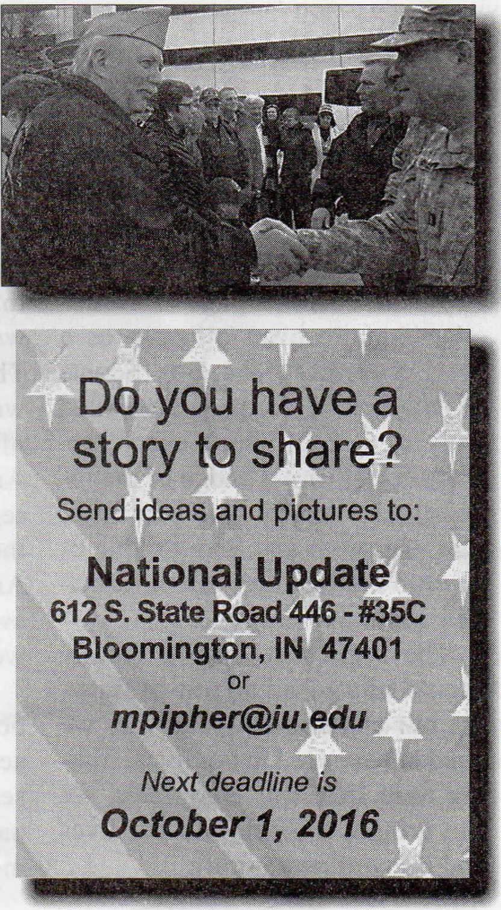
to help voters get registered, help them get to the polls on voting days, or sign up to work at a poll- ing station. Ifyour post is used as an official polling place, that pro­ vides opportunity for you to be in­ volved in many ways; making the facilities accessible to all, provid- ing assistance for disabled voters, provide refreshments for voters or and/or poll workers, provid- ing transportation for voters, etc. Even before an election, you can help arrange absentee ballots for military personnel deployed over- seas.
Our duty as citizens is to exer­ cise the right to vote and truly par­ ticipate in the democracy that our forefathers set up. Voting ensures future freedoms.
You can help make vote totals reach new highs this November, both, in total numbers of votes cast and with high percentages of eligi­ ble voters actually casting ballots.

The Sons of The American Legion
Non- Profit Organization
U.S. Postage
PAI D
THE
AMERICAN LEGION

P.O. Box 1055
Indianapolis, IN 46206 I

'J

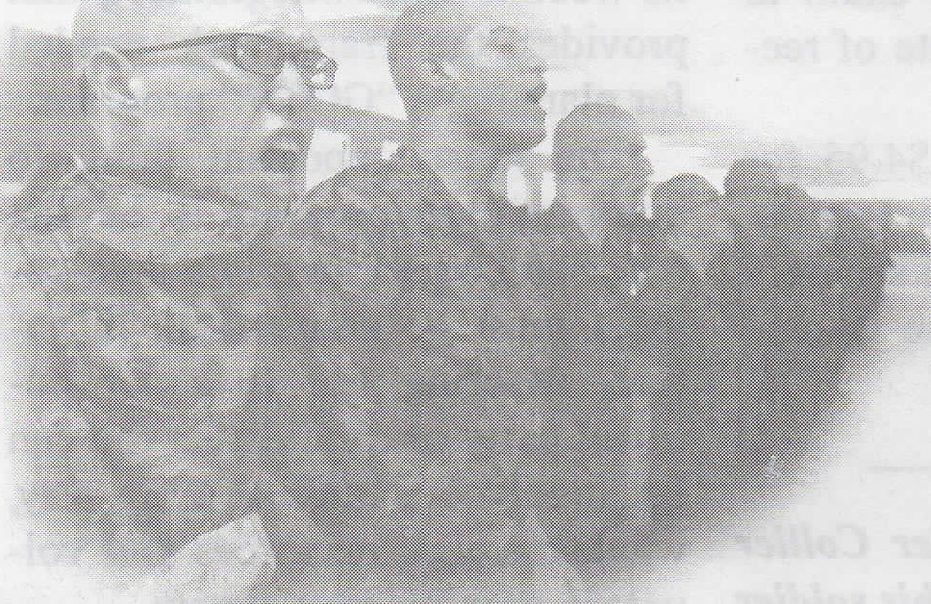
IIII I• I''I•II1••1•••111l I III1•• 1I1•••••1•1•I''I I•••111•II••• 1•1• I
35 *************AUT0**3-DIGIT 554 **** 228197
260877193
8

8
God from Page 2
for
We need to use all resources at our disposal to get behind these groups and help them succeed. However, it is not just the duty of our Chaplain to bring God back into the lives of our community. It takes everyone to join together and get involved with our youth and Community Service programs and with memorial services that include the community. Take it one step further during the typical holiday times of year, a time when most everyone thinks of helping those less fortunate than ourselves. We could do Thanksgiving baskets for the needy, Christmas parties for children, stocking stuffer pro­ grams, visitations to VA hospitals and to the homes of vets who can't

get out.
What's important about this kind of work is that it should not be focused on just one time of the year. We need to bring forth the presence of God year round.
We can take a page from an­ other Americanism program as a good resource. The Boy Scouts of America have a program called Duty to God in which every par­ ticipant can earn a badge of the re­ ligious emblem for their own faith. You can go to any Scout office or go onto the web for more informa­ tion about that program.
The American Legion Family should take a leading role in show­ ing our children how and why we need to have God in our lives. Tak­ ing time from our busy lives, we can bring God back into our lives and into our community.

New Handbook for Americanism ready
The Sons of The American Legion Americanism Handbook has been updated and is available to download from our national web site at www.legion.org/sons. The nine page booklet contains a wealth of information about many of the programs that fall under the Americanism pillar of service and serves as an adjunct publication to the much larger American Legion Americanism Manual, which is available from The Legion's own web site at www.legion.org.
The S.A.L. Americanism Hand­ book provides suggestions _.... activities that cover communi.1 service projects, youth programs, patriot observances, and much more.

