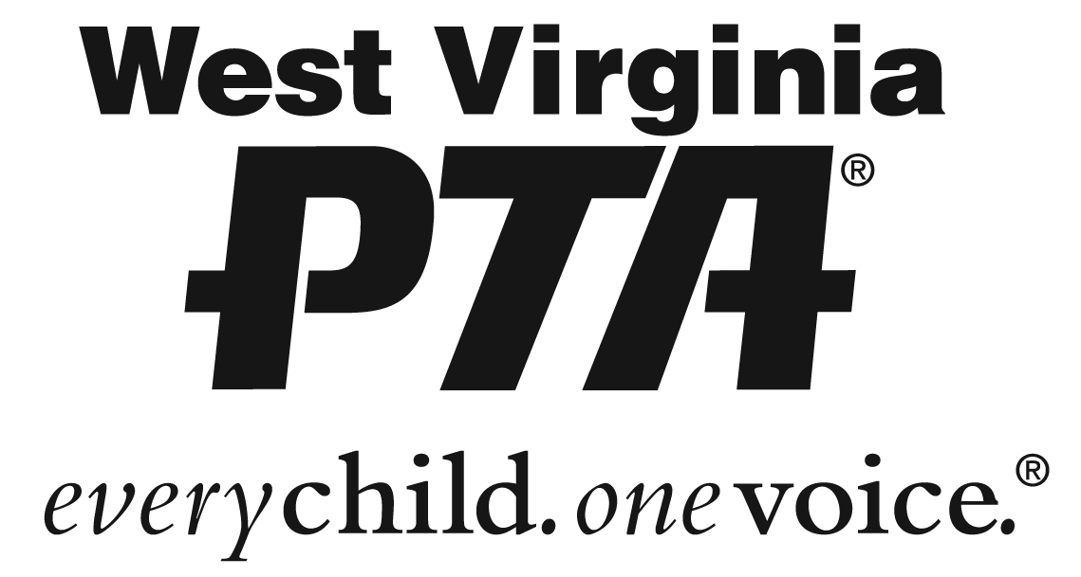

Local PTA Membership Marketing Plan

BACKGROUND

Developing a marketing plan for your PTA can help you attain your PTA goals in a strategic and purposeful way.

In PTA we do great things for kids at our local, regional, state and national levels, but sometimes our community members don’t know what we do. Marketing your PTA serves many purposes but for our marketing plan we will focus on:

- Increasing awareness
- Increasing membership
- Developing loyalty

Once you understand the principles, you can apply them to any marketing goal. Fortunately, with nearly 120 years of service, PTA has a well known brand. Companies spend lots of money to make sure their brand is known—we have that BUT—we want to make sure PTA is known for the right reasons.

DEVELOPING YOUR PLAN

Ask these questions:
- Who do we want to be aware of what we are doing? (Audience)
- Who do we want to join? (Audience)
- What message you need to deliver to that audience? (Key Messages)
- Who is the best person (Key Influencer) to deliver that message?
- What is best way to deliver that message? (Delivery Method)
- How will we retain, engage, support our members?

In marketing, the goal is to deliver the right message (key message) to the right audience (potential member) by the right person (key influencer) in the right way (how).

This doesn’t mean changing your key message, just targeting it…Parents want to know what the local PTA is going for their kids at their school, Teachers want to know what PTA is doing for them at their school and they might care about advocating for Education funding in Sacramento. So targeting the message helps the audience know what’s in it for them.

Having a key influencer deliver the message maximizes the input—for example a teacher can speak to fellow teachers, a parent of a first grader can speak at Kindergarten orientation about how they felt the year before, a person who speaks another language can speak to parents or community members who speak that language.

Key method is how you will deliver the message. In person, on a flier, on social media, in an email, poster, broadcast etc.

Start with your biggest potential audiences. At a school site, your largest audiences are parents, teachers/staff, students and past members. Then move to target group of people in the school community who have not joined, attend ESL meetings, booster club meetings,

MARKETING PLAN WORKSHEET

Our PTA’s overall membership message is…

Timing/  Scheduling | Key Audience | Targeted Message | Key Influencer | Delivery Method
 | Parents
 | Teachers/Staff
 | Students
 | Past Members
 | School Administrators
 | School Board Members
 | Community Leaders
 | Local Business Leaders

EXAMPLE:
Timing  Scheduling  (When) | Audience  (Who) | Key Influencers  (Who) | Key  Messages  (What) | Key  Medium  (How) | Notes:
Before School Starts | Past members | PTA president | Please continue to support PTA. | Emails, letters, phone calls,  Social media posts
Before School Starts | Teachers/  Staff | Teacher leaders/PTA President | Highlights of what PTA does for the school and teachers | Email, flyers, Welcome back event | Invitations in all staff mail boxes
Orientation | New Families | Parent PTA Leader | What your PTA does for your students at your school | Speech, flyer with PTA highlights | PTA Table with resources and happy PTA volunteers
Back-to-School Night | Families/ community members | Variety of PTA volunteers/  Teachers | Welcome-what PTA does for students, teachers, the community | Table, posters, resources, flyers | PTA Table with resources and PTA happy excited volunteers
First few weeks of school | Families | Variety or PTA volunteers | Highlight programs for students | Contests, displays, flyers, social media, emails, | Do a big push but limit it so there is a deadline – you could have a PTA table in front of school.
TBD | ESL Families | Someone from that group | What PTA does for your students and for you parents | In person | Maybe a few minutes at a meeting followed by one on one
TBD | School Site Council | Someone from that group | What PTA does for school | In person
Year Round | New Families | School office staff | Welcome, What PTA does at the school, calendar, etc. | Welcome packet | Assemble several welcome packets and work with school to distribute to new families as students enroll.
School and PTA Events  Back-to-School Evening | School Community | Happy volunteers | PTA sponsors/puts on this program and more | In person, flyers, posters pictures of events | Table at each event
November |  |  | Thank you | Social media, personal note, email blast, posters
May | Teachers | Parents and students | Thank you—teacher appreciation | Social media in person | Thank you, appreciation event
June | Current members |  | Re-join | email

