ATTENTION!
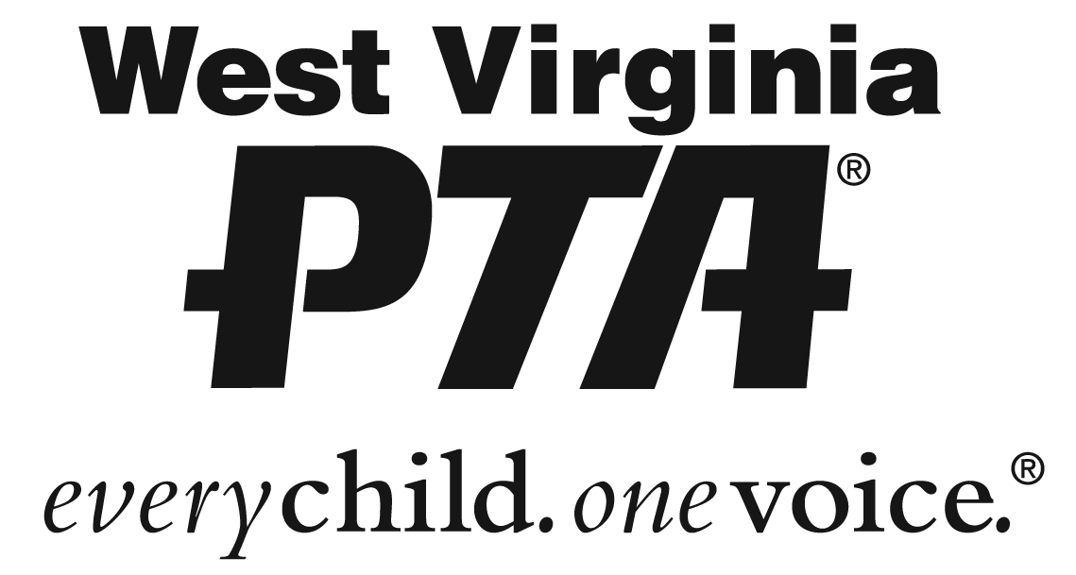
West Virginia PTA Membership Campaign
for Diverse Families

The West Virginia PTA is embarking on a campaign to include families of diversity including children with special needs, into the PTA. The Board of Managers recently adopted a proposal to pay state and national dues for two memberships per school for diverse families. We are hoping that each local unit will waive their dues portion so we can begin a journey of being more inclusive to these families!
Each local unit may decide how to choose the two memberships. Once they have been selected, please include their names and contact information with your monthly membership dues form for that month, so that we can send them valuable resources. We have attached the following form to provide this information to the state. This is an exciting time for West Virginia PTA! Please support the inclusion of a diverse family in your local unit and promote this offer. Diversity can mean a wide range of descriptions including special needs and disabilities, race, ethnicity, language, religion, and even grandparents and foster parents!
The West Virginia PTA developed a diversity committee as a focus during the 2017-2019 school years. Furthermore, the committee is developing informational workshops for diverse families at the State Convention in Bridgeport in April, 2018. The conference would be for both parents and children. Parents would receive valuable training and information and children would have an opportunity to be engaged in activities including music, painting, cooking, and STEM!
The committee is very excited about the upcoming year. If you would like to be a part of this new adventure, please contact Ginnie Molnar at diversity@westvirginiapta.org.

